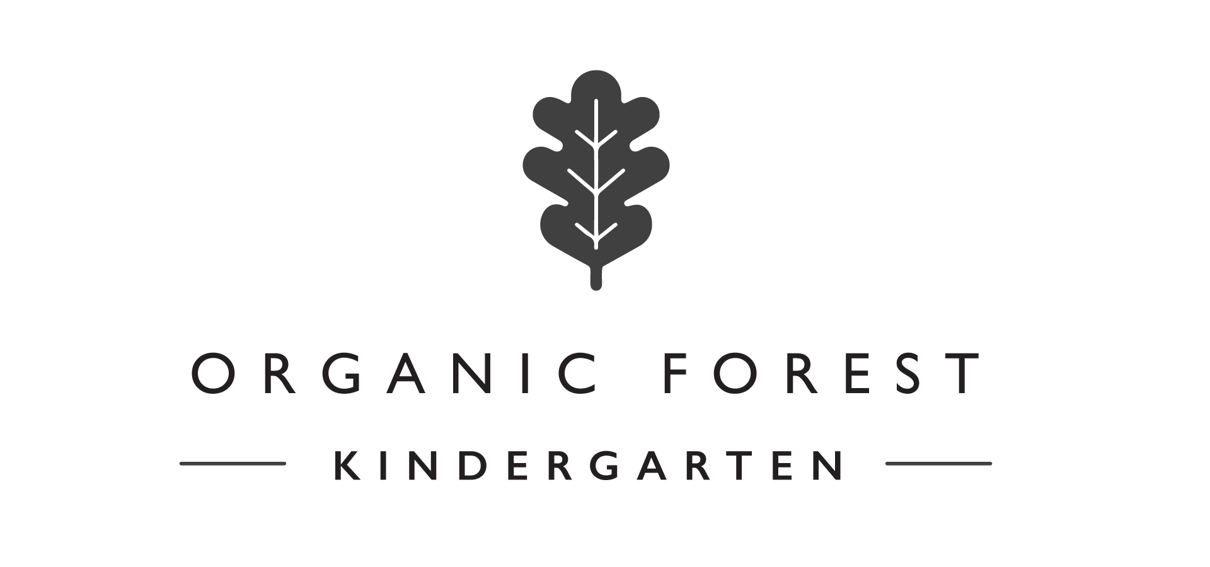

2020 Registration Form (CONTRACT)

Child’s Full Name:

What would you prefer your child to be known as at Saplings?

Male Female Date of birth:

Home address:
Post code:

Who has parental responsibility for your child?

Parent 1 Parent 2 Both Other (please state)

If you intend to use childcare vouchers, please detail the scheme(s) you will be using:

Parent 1 / Guardian's details:
Parent 1 / Guardian’s name:
First Last
Parent 1 / Guardian's Home and Mobile number:
Parent1 / Guardian's workplace:
Parent 1 / Guardian's work number:
Parent 1 / Guardian's email:
Parent 2 / Guardian’s Details:

Parent 2 / Guardian's name:
First Last
Parent 2 / Guardian's home & mobile number:

Parent 2 / Guardian's workplace:
Parent 2 / Guardian's work number:
Parent 2 / Guardian's email address:

Alternative contact
Please provide an alternative contact that is additional to the parents and ensure you have permission from named person to give us their details

Name of alternative contact:
First Last

Relationship to child:
Alternative contact number:

Regular sessions
Please enter a ‘X’ under the regular sessions you would like your child to attend Saplings Forest School on a term time basis.

Session times: 8:30am – 1:30pm
Monday Tuesday Wednesday Thursday Friday

Session times: 8:30am – 3.00pm (15 Universal hours to be taken between hours of 8.30am to 1.30pm ONLY)
Tuesday

I will be using part or full 15 UNIVERSAL HOURS OFFER:
I will be using part of 30hrs EXTENDED HOURS OFFER:

Preferred start date at Organic Forest Kindergarten:

Any additional comments:

Where did you find out about us?

It is important for us to communicate with other settings your child may attend to support their development and learning. If you are planning on using more than one setting, please provide the name & address of the other provider (including childminders).

Health information
Doctor / health visitor information

Doctor’s name:
Doctor’s telephone number:
Doctor’s address:
Post code:

Health visitor’s name and telephone number:
Health visitor’s address:
Post code:
Current vaccinations and dates:
Vaccination: | Date:
Allergies:
Where there are allergies please provide as much information as possible.

Any relevant medical information:

Are there any other professionals involved with your child (CAF, My Plan etc). If so, please provide details: Use overleaf if needed.

Any relevant dietary needs:

What is your child’s preferred language at home? Please include any other languages used at home too.

Do you follow a particular religion at home? If so, please tell us so we can help your child celebrate key points during the year.

Collecting your child

Other people collecting
If there are any other regular people, other than parents / carers, who may collect your child then please complete their details below. Please ensure you have permission to give us their details

Collector One (different to parents / carers)
Name:
First Last

Collector One’s telephone number:
Description of collecting person:

Relationship to child:
Secret question:
Secret answer:

Collector Two (different to parents / carers)
Name:
First Last

Collector Two’s telephone number:
Description of collecting person:
Relationship to child:
Secret question:
Secret answer:

Declaration
Registration & Fees
A non-refundable registration fee of £55 is payable for each child registered with OFK, payable at the point of returning this Contract Registration Form. This includes a set of high quality Didriksons Waterproofs (as used in Swedish Forest Schools).

Recording & sharing of evidence
I confirm my permission for photographs to be taken of my child for creating evidence of learning for the Early Years Foundation Stage (EYFS).

I confirm that I give permission for OFK to contact my child’s previous setting(s) for relevant information/documentation to support my child’s development and wellbeing. I also give permission for OFK to forward relevant information/documentation to my child’s new setting should the parent choose to move their child, in order to support their development and wellbeing.

I give my permission for OFK to contact other professionals in relation to supporting my child’s health, welfare and for safeguarding purposes. This may include, but not be limited to health visitors, speech and language therapists, inclusion officers etc. We are proud of our parent partnership and will of course work with you closely prior to any contact being made, with all parties being informed.

Records will be stored confidentially and access may be gained by providing a written request to the Manager (see our Data Protection and Confidentiality Policy for further details).

Visits / trips
I confirm my permission for my child to attend pre-planned visits / trips including off site walks in the country side.

Medical
I confirm my permission for first aid to be administered to my child as deemed necessary by a qualified first aider.

Photographs of setting
I confirm my permission for photographs that include my child to be used for displays and marketing (including online social media platforms).

Terms and conditions
I confirm that I have read and accept the Terms and Conditions found overleaf and Saplings Policies and Procedures.

Declaration

I confirm that all the information given on this form is true and correct.
I confirm that I have transferred £55 non refundable Registration Fee to secure my child’s place at OFK (which will also secure a set of high quality Didrikson’s waterproofs upon starting). I understand if I change my mind about my child starting at OFK, this £55 is non refundable.

Please return the registration form via email to saplingsforestschool@yahoo.com or to :

Dionne Pullen

Managing Director

1 The Old Barnyard

Rushall

Wiltshire

SN9 6BF

Registration fee bank transfer of £55 per child may be sent to:

Sort code – 09-01-29
Account Number - 09239274
Reference – your child’s name

Terms and conditions

Your obligations:

- Children must be at least two years old to come to OFK.
- £2.80 daily charge will be payable by parents who claim any part of the Universal or Extended hours offer. This is invoiced and payable before the start of each half term.
- For families in receipt of the 30 hours Extended offer, it is THE PARENTS RESPONSIBILITY TO GIVE US RENEWED CODES 4 WEEKS BEFORE THE START OF EACH TERM otherwise funding may by withdrawn and private fees charged in accordance to our policies. Places for the Extended Offer are only available upon receipt of a valid code.
- We ask for 4 weeks written notice to be given to us should you wish to remove your child from OFK or to change any sessions. Fees will be due during this 4 week notice period.
- The Registration Fee includes your child’s first set of waterproofs. You will be required to ensure your child is dressed in these waterproofs everyday they are in attendance to meet our Safeguarding procedure (apart from in warm weather). These waterproofs are yours to keep so feel free to use on weekends, holidays etc, in addition to your child’s time at OFK. When your child outgrows their waterproofs, we can supply the next size up for a fee of £40. If you wish to purchase more than one set to ease washing duties(!), these are available upon request. You are of course welcome to speak to other parents and use sets that have been outgrown.
- Parents to supply nappies, wipes, lunch and drink. Water and organic milk is available throughout the day.

In addition to the waterproofs provided, we recommend the following kit list:

What to wear in Spring/Autumn:

*Waterproofs, as provided by Saplings
*Pair of comfy trousers (jogging bottoms/leggings)
*Long sleeved t-shirt/top
*Thick jumper
*Fleecy zip up jacket (in the backpack, just in case)
*Two pairs of socks (one thin pair on first and the second thicker (bed sock type) over the top)
*Warm hat and gloves
*Warm lined wellies or closed toe sturdy outdoor shoes (which you don’t mind getting muddy and wet! Also, not standard wellingtons as these are not sufficient at keeping feet warm).

What to wear in Winter:

*Waterproofs, as provided by Saplings
*Base layer – thermal trousers and top
*Fleece or other warm tracksuit bottoms
*Long sleeved top (2 long sleeved tops may be required in colder weather)
*Fleece jumper
*Fleece jacket
*Coat
*Neck scarf AND warm hat and gloves (spare gloves packed in backpack)
*Four pairs of socks with two pairs worn as in Autumn with the other two as spares in backpack.
*Extra jumper packed in backpack
*Snow boots or sturdy warm outdoor boots (not standard wellingtons as these are not sufficient at keeping feet warm).

If your child is potty training or recently new to toileting, please ensure you pack lots of spare underwear!

Our obligations

We will inform you as soon as possible whether your application for a place at OFK has been successful. If a place is not available, you will be placed on a waiting list for your preferred days, on a first come, first served basis.

We will provide the agreed educational and welfare facilities for your child at the agreed times (subject to any days OFK is closed as per our Policies and Procedures). If we change the opening hours of OFK, we will give you as much notice as possible (minimum of 4 weeks notice of changes to our services). Please note that our times of the day are fixed and we do not facilitate ad-hoc drop-offs and pick-ups at alternative times.

We will try to accommodate any requests you may make for any additional days at OFK to the best of our ability. Ad-hoc days will be charged in advance and payable in advance. To reduce sessions, we require 4 weeks written notice. We also commit to giving you 4 weeks notice of any permanent change to our opening hours.

We will provide organic snacks and organic milk to all children (or water where children are vegan or have other special dietary needs upon request).

Safeguarding children is our highest priority. This means taking measures to ensure their safety and welfare. This may include contacting the appropriate professionals and authorities for safeguarding concerns. By signing the Registration Form, you are giving permission for us to do so.

We will provide you with daily verbal updates, regular electronic and written updates as to your child’s progress.

We will notify you as soon as possible of any days on which OFK will be closed as per our Policies and Procedures.

Fees are subject to an increase once per year.

Financial Terms and Conditions:

We accept children who are eligible for the UNIVERSAL AND EXTENDED 15 hours and 26.5 of the 30 hours government funding scheme (26.5 hours available each week due to opening times). Universal funded hours maximum of 570 hours over 38 weeks. Extended funded hours 1,007 hours over 38 weeks.

Additional Fees:
Late Collection Fee (funded and private attendance) | £1 per minute late
Registration Fee | £55 per child non-refundable (includes a set of high quality waterproofs).

Funded Children:
From September 2019, a daily charge of £2.80 is in place for all funded children, which is implemented to cover the cost of inflation, organic snacks, resources and overhead charges to enable to setting to operate and be sustainable – this is NOT a top up fee, but there to ensure we are able to continue to provide high quality education and care.

This charge is normal practice for Early Years settings as the current funding rate has been slashed by over 20% in the last 3 years, and with 10’s of settings closing each week across the Country, this fee is to help provide the much needed funds to cover the costs of providing a unique and unrivalled setting for your child to enjoy and thrive within.

Fees are invoiced on a half termly basis and payment due in advance and within seven or fourteen working days of receipt of invoice – see invoice for details. Invoices will be emailed to parents prior to the start of each half term in accordance to this contract. OFK accepts childcare vouchers – it is the parent’s responsibility to let us know of their voucher provider prior to their child starting with us.

30 hours extended offer – it is the PARENT’S RESPONSIBILITY to inform us of their renewed and valid code 4 weeks before the start of the new term

Unpaid fees are subject to interest. We will send a reminder invoice one week after the initial deadline requesting immediate payment. If fees remain unpaid, we reserve the right to withdraw your child from Saplings Forest School. If required, we will seek legal advice.

Fees are subject to review each year – OFK will aim to give at least 4 weeks notice of any fee increase.

